**STEPPER MOTOR LOAD CALCS AND TYPES**

Typical bipolar stepper data sheets define amps/phase, phase resistance, rated voltage, phase inductance, holding torque and step angle (see below). Calculations to determine actual power supply power loads when driven by a motor driver IC (e.g. Trinamic TMC2209) for two phase steppers are not intuitive. The Duet guidelines for determining power supply sizing when utilizing their Duet 2 WiFi V1.04 control board are as follows:

*Stepper motors: at full rated current, the power needed for each motor is its rated current times its rated voltage (if no rated voltage is specified, use the square of the rated current times the phase resistance). This is the power at standstill. To allow for driver losses and the extra power needed to create acceleration, add 50%. Multiply by the number of stepper motors.*

In an observed test of 5 NEMA 17 0.9 deg steppers (specific model not known) connected to a Duet-like control board with a 24 VDC power supply, the total DC current supplied to the drivers during varied concurrent actuations was not observed to exceed approximately 1 amp, even with applied loads. Based upon this result, the power required by the 5 NEMA 17 stepper motors from the 24 VDC power supply in this instance would be approximately 24 watts or 4.8 watts per stepper motor.

Since the specific phase current, phase resistance or phase voltage were not known for the observed test detailed above, the values for the planned BARN large printer NEMA 17 steppers will be utilized to attempt to verify the Duet-suggested guidelines for power supply sizing. The NEMA 17 stepper motors selected for the “Z” axis: OSM Technology, P/N 17HM19-1684S, have a phase current of 1.68 DC amps, phase resistance of 1.65 ohms, phase voltage of 2.8 VDC, phase inductance of 4.1 mH and a holding torque of 0.42 Nm.

**DUET Suggested Stepper Power Calculation Method #1**

If the Duet-suggested power supply sizing guidelines for stepper motors are applied, the following power consumption estimate per stepper is found:

**Psp = (Iph)2*Rph**

NEMA 17 Motor

**Psp** = Stepper Power

**Iph**= Rated Phase Current 1.68 Amps

**Rph** = Phase Resistance 1.65 Ohms

**Psp =** (1.68)2*1.65 = 4.66 Watts

This is close to the results from the observed test, where individual stepper power was observed to be approximately 4.8 watts.

If the suggested *50%for driver losses and the extra power needed to create acceleration* is added, stepper power is estimated at **6.99 watts**.

**Alternate Stepper Power Calculation Method #2**

Further investigation into the impact of power supply voltage level (24 VDC versus 12 VDC) on stepper motor power requirements identified another method of stepper power estimation taking into account the power supply voltage level. The formula that takes power supply voltage into account is as follows:

**Isc = (Vmot / Vps)*C* Iph*M**

NEMA 17 Motor

**Isc** = Stepper Power Supply Load Current

**Vmo**t = Stepper Phase Voltage : 2.8 VDC

**Vps** = Power Supply Voltage : 24 VDC

**C** = Number of Coils (Usually 2) : 2

**Iph** = Stepper Phase Current : 1.68 Amps

**M** = Margin of Safety : 1.5

**Isc =** (2.8/24)*2*1.68*1.5 = 0.588 amps (Drawn from 24 VDC PS)

This current would require **14.11 Watts** at 24 VDC to be drawn from the 24 VDC power supply.

Comparing the two methods of stepper motor power consumption, it appears that major difference is that Method #2 includes a multiplier for the number of coils, in this case 2. Thus, if the coil multiplier was used in Method #1, the predicted power would be 13.97 watts, close to the 14.11 watts predicted by Method #2.Based upon this it is proposed that Method #2 be utilized to predict DC stepper motor current loads for power supply selection. In addition, I would propose a 75% Margin of Safety instead of the 50%.

Based upon the proposed Method #2 stepper power estimation formula, the following are estimates for our selected steppers:

**X & Y Steppers (NEMA 23) P/N 23HM22-28045**

**Isc = (Vmot / Vps)*C* Iph*M**

= (2.5/24)*2*2.8*1.75 = 1.02 amps from 24 VDC power supply (24.5 watts)

**Z Steppers (NEMA 17) P/N 17HM19-16845**

**Isc = (Vmot / Vps)*C* Iph*M**

= (2.77/24)*2*1.68*1.75 = 0.68 amps from 24 VDC power supply (16.29 watts)

**Extruder Stepper (NEMA 17) P/N 17H54023**

**Isc = (Vmot / Vps)*C* Iph*M**

= (4.1/24)*2*1*1.75 = 0.60 amps from 24 VDC power supply (14.35 watts)

**Tool Stepper (NEMA 11) Not ID’d**

**Isc = (Vmot / Vps)*C* Iph*M**

= (2.66/24)*2*0.95*1.75 = 0.37 amps from 24 VDC PS (8.84 watts)

**STEPPER POWER REQUIRED**

3 Z Steppers: 3*16.29 = 48.87 Watts

X and Y Steppers: 2*24.5 = 49 watts

Extruder Stepper: 14.35 watts

Tool Stepper: 8.84 watts

**TOTAL 121.06 watts**

**EXTRUDER STEPPER (17HS4023)**

Usongshine NEMA 17 Stepper Motor Bipolar Step Motor for Titan Extruder 3D Printer 4.1V 1A 13Ncm (18.4oz.in) 4 Lead 1.8 Deg with 1m Cable (17HS4023)

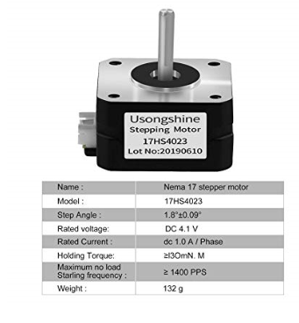

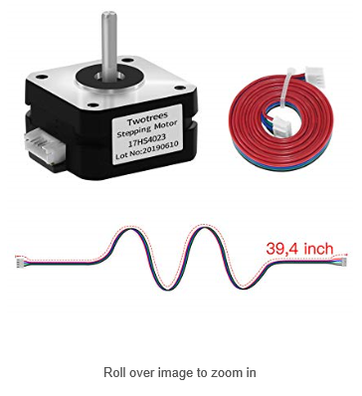

**X, Y STEPPERS (23HM22-2804S)**

STEPPERONLINE 0.9 deg NEMA 23 Step Motor Bipolar 1.26Nm (178.4oz.in) 2.8A 4-lead

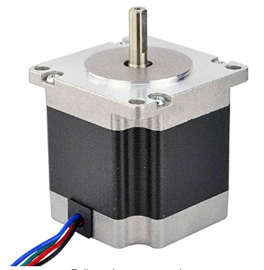

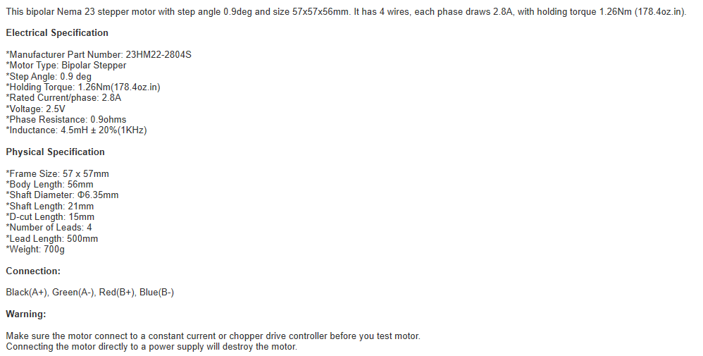

**Z STEPPERS (17HM19-1684S)**

STEPPERONLINE NEMA 17 Bipolar Stepper 0.9deg (400 steps/rev) 1.68A 44Ncm (62.3oz.in) Motor

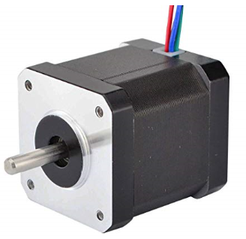

OSM Technology Co., Ltd

[.](https://www.amazon.com/s/ref=bl_dp_s_web_0?ie=UTF8&search-alias=aps&field-keywords=OSM+Technology+Co.%2CLtd.)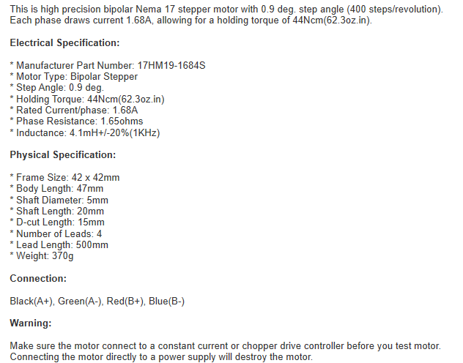

**TOOL STEPPER**

TBD